Equivalent Fractions Name: ____________ Date: __________
Developing Understanding - Each of the shapes are the same size whole, however the shapes are divided into different equal parts.
Your task is to represent ¼ for each of the shape and write the fraction next to the shape.
1. | 2.
3. | 4.

Below are same whole shapes as above, however the shapes are divided into different equal parts. Your task is to represent $\frac{1}{3}$ for each of the shape and write the fraction.
1. | 2.
3. | 4.

Developing fluency – Solve the following equivalent fractions…
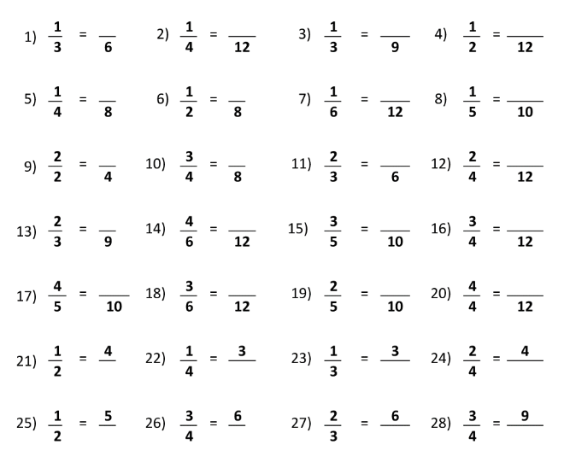

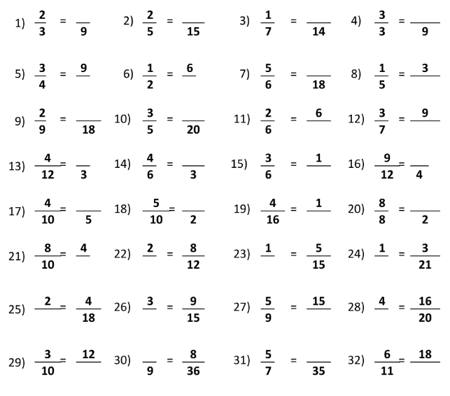
Assessment – Provide each student with the stimulus and an A4 blank sheet of paper to complete the following task.
