Solve the following multiplication problems (A) |  | Solve the following multiplication problems (B)
1 | a. 7 x 8 = ______ b. 4 x 5 = ______  c. 6 x 6 = ______ c. 9 x 3 = ______ | 1 | a. 9 x 7 = ______ b. 5 x 6 = ______  c. 7 x 6 = ______ c. 8 x 8 = ______
2 | 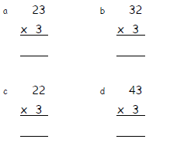 | 2 | 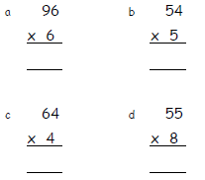
3 | 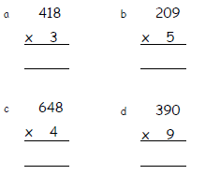 | 3 | 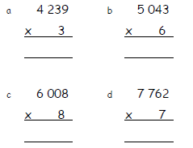
4 | 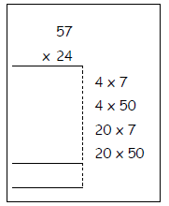 | 4 | 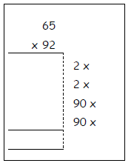
5 | 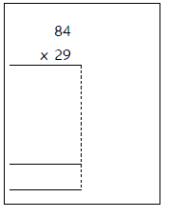 | 5 | 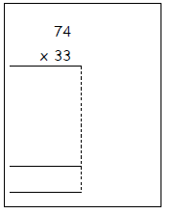
6 | 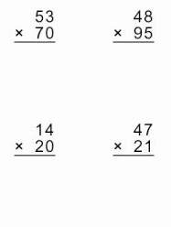 | 6 | 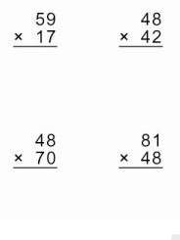
7 | 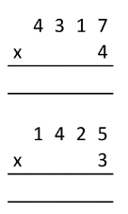 | 7 | 